C.V. RAMAN GLOBAL UNIVERSITY

BHUBANESWAR, ODISHA, INDIA



DEPARTMENT OF ECE

CASE STUDY REPORT ON

**DIGITAL TICKET BOOKING AND RESERVATION SYSTEM**

**Submitted By: -**

|  |  |
| --- | --- |
| REGISTRATION NO. | MEMBER’S NAME |
| CL20250106019052110 | Sameer Nayak |
| CL202501060188235 | Ajay Kumar Marandi |
| CL2025010601934852 | Chandrasekhar Parida |
| CL20250106019059117 | Satyanand Kumar Chauhan |
| CL20250106019060118 | Satyajit Mishra |

GROUP:14

SEMESTER:6TH

BRANCH: Electronics & Communication Engineering

# CONTENTS

1) Acknowledgement

2) Abstract

3) Introduction

4) Objectives

5) System Overview

6) Methodology

7) Features and Functionalities

8)Implementation of C++

9) Output

10) Advantages & Limitations

12) Conclusion

# 

# ACKNOWLEDGEMENT

We express our sincere gratitude to all those who contributed to the successful completion of this project. We extend our heartfelt thanks to our mentors, instructors, and peers for their valuable guidance and continuous support throughout the development of this system. Their constructive feedback and encouragement played a crucial role in refining the project.

We also appreciate the online resources and documentation that helped us enhance our understanding of C++ programming and system design. Lastly, we acknowledge the collaborative efforts of our team members, whose dedication and hard work made this project possible.

# ABSTRACT

The Digital Ticket Booking and Reservation System is a C++-based application that simplifies the ticket booking process for movies, trains, buses, and concerts. The system provides a seamless user experience through a menu-driven interface, ensuring efficient booking with secure authentication, seat selection, and unique booking ID generation. It eliminates manual errors, reduces wait times, and enhances accessibility.

The system incorporates structured programming, data validation, and random number generation for unique IDs. Although the current implementation uses in-memory storage, future enhancements like database integration, online payments, and a graphical user interface (GUI) will make it a scalable and fully functional ticket reservation platform

**Introduction**

In today's fast-paced digital world, traditional ticket booking methods are becoming obsolete, making way for automated and efficient systems. A Digital Ticket Booking and Reservation System simplifies the process of booking movie, train, bus, and concert tickets, ensuring a faster, more reliable, and user-friendly experience. This system allows users to register, log in, select tickets, choose seats, and confirm bookings seamlessly. By eliminating manual errors, reducing wait times, and enhancing accessibility, the system provides a hassle-free booking experience. Features like unique booking ID generation, seat selection, and instant confirmation make it an effective and structured solution. With further enhancements such as database integration and online payment options, it can become a fully functional and scalable ticket reservation platform catering to a large user base.

**Objectives**

The primary objectives of this system are:

* To provide a **user-friendly** ticket booking platform.
* To ensure **secure login** and **registration** for users.
* To offer multiple **ticket types** and **seat options**.
* To generate a **unique booking ID** for tracking.
* To display a **detailed booking confirmation**.
* To improve efficiency and reduce errors in ticket booking.

**System Overview**

The system is designed as a **menu-driven C++ application** that allows users to:

1. **Register/Login** to access the ticket booking system.
2. **Select a ticket type** (Movie, Train, Bus, or Concert).
3. **Choose seat category** (General, VIP, First-Class, or Economy).
4. **Enter event details** and seat location.
5. **Generate a unique Booking ID** and display a booking summary.

The system ensures data validation, preventing invalid input and duplicate usernames. It also provides a **user-friendly interface** for quick and hassle-free bookings.

**Methodology**

The project follows a structured approach:

* **Programming Language:** C++
* **Data Structures Used:**
  + struct for storing ticket details.
  + map for user authentication.
* **Random Number Generation:** Generates a **unique Booking ID**.
* **Error Handling:** Ensures valid inputs for seats and ticket types.
* **User Input Handling:** Allows users to enter event details dynamically.

**Features and Functionalities**

* **User Authentication:**
  + New users can **register** and create an account.
  + Existing users can **log in** with a username and password.
* **Ticket Booking:**
  + Users can **select** between **Movie, Train, Bus, and Concert** tickets.
  + Option to **enter event details** dynamically.
* **Seat Selection:**
  + Choose from **General, VIP, First-Class, or Economy** seats.
  + Enter **specific seat row and number** for better customization.
* **Booking ID Generation:**
  + Every booking gets a **randomly generated 5-digit ID** for uniqueness.
* **Booking Summary:**
  + Displays **ticket details, seat type, seat location, and Booking ID**.

**C++ Implementation**

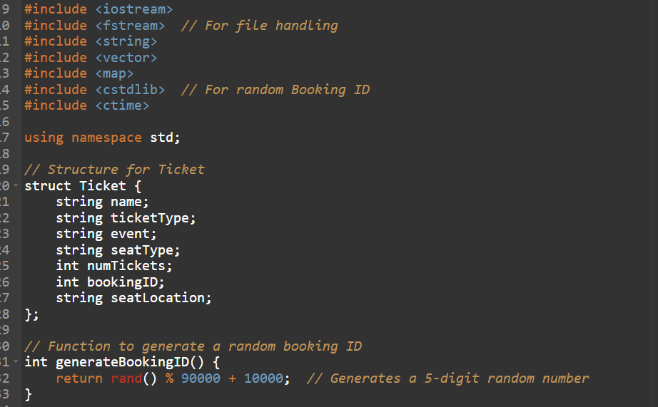

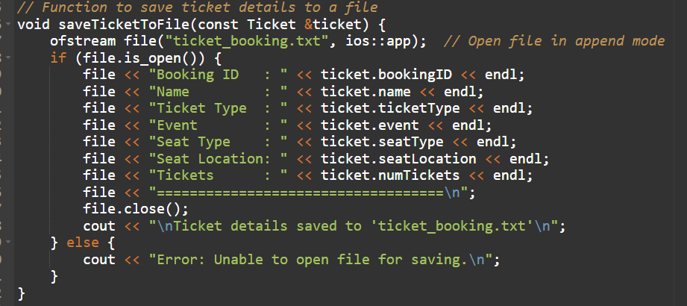

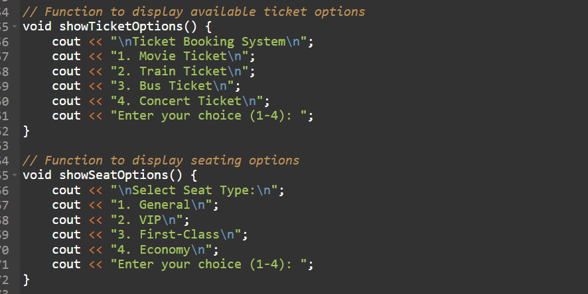

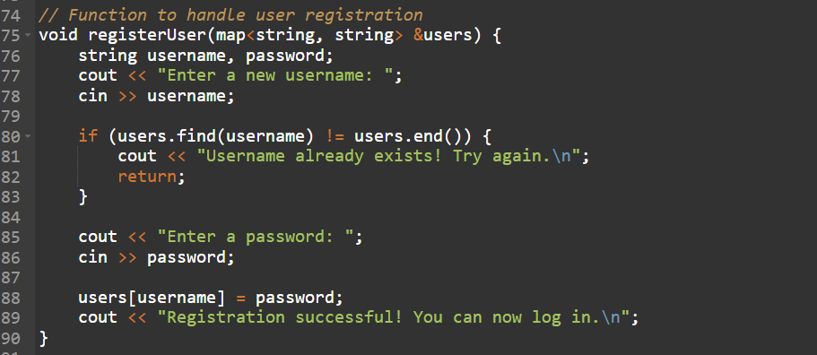

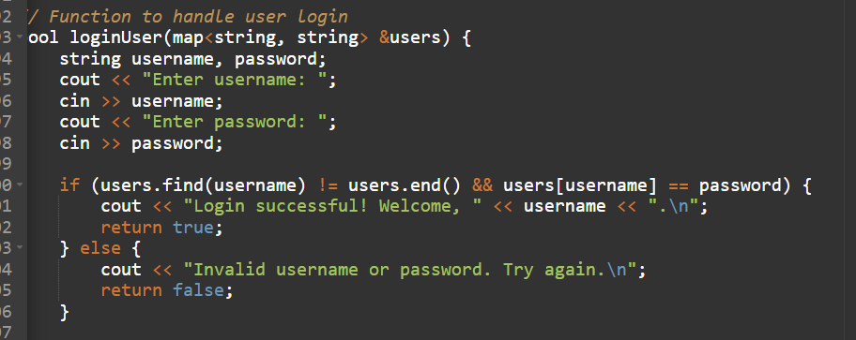

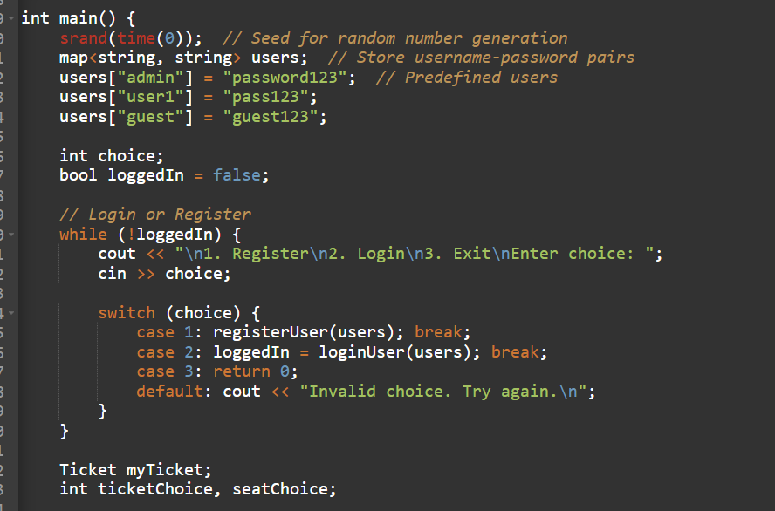

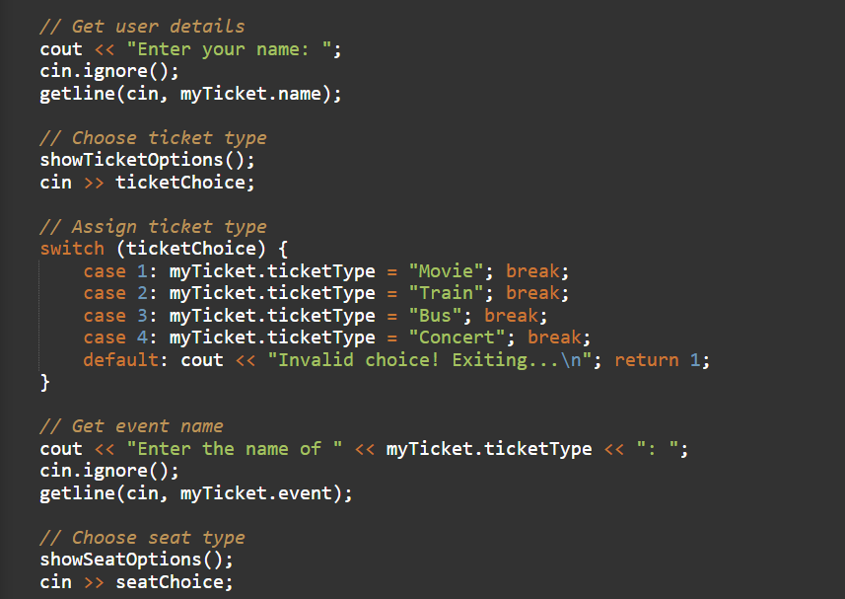

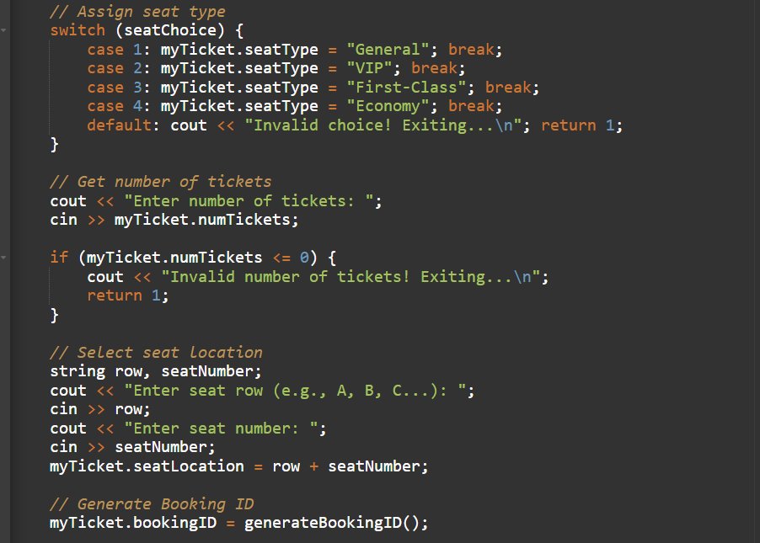

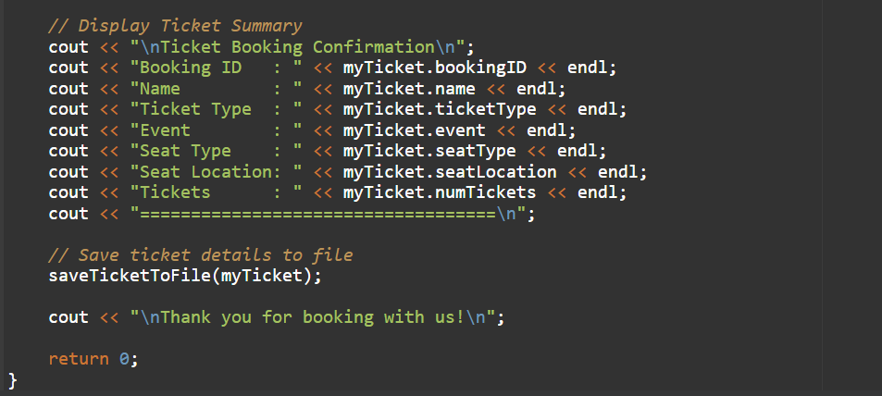

**OutPut**

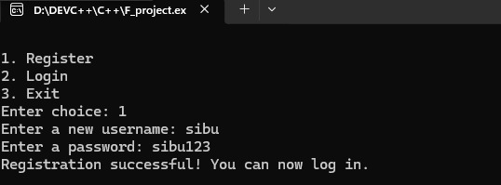

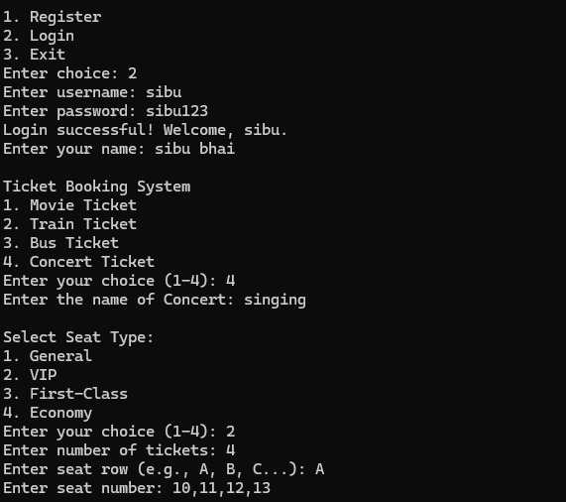

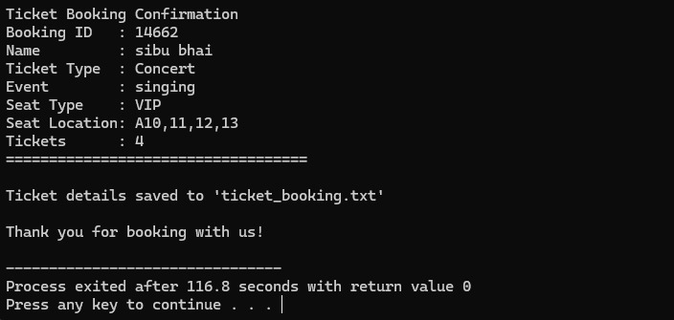

**Advantages & Limitations**

* **Advantages:**  
  a. Reduces manual booking effort.  
  b. Ensures security through authentication.  
  c. Generates unique booking IDs for tracking.  
  d. Enhances user experience with seat selection.
* **Limitations:**  
  a. Lacks a graphical user interface (GUI).  
  b. No online payment integration.  
  c. Uses in-memory data (no database).

**Future Enhancements**

* **Integrate a database** for storing user and booking data.
* **Add online payment** for ticket purchases.
* **Develop a GUI** for better user experience.
* **Implement cancellation & refund policies.**

**Conclusion**

The **Digital Ticket Booking and Reservation System** provides a simple and efficient way for users to book tickets for movies, trains, buses, and concerts. It includes **user authentication, ticket selection, seat allocation, and booking confirmation** with a unique **Booking ID** for tracking. Future enhancements such as **database integration, a graphical user interface (GUI), and online payment options** can improve its functionality. Features like **cancellation, refunds, and automated notifications** would further enhance the user experience. With these improvements, the system can become a **fully functional and scalable ticket reservation platform**.